1st Color Palette:

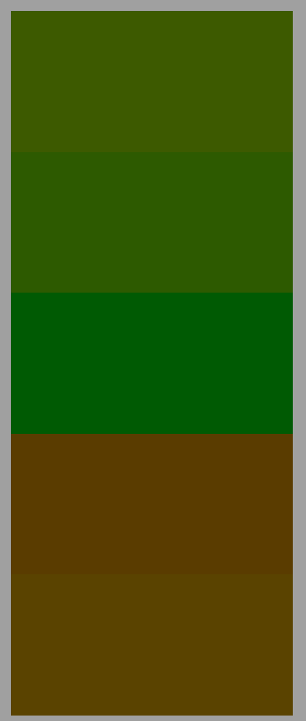

RGB (From Left to Right):

1. 3d5a00 – Olive green
2. 2d5a00 – Medium green
3. 005a03 – Forest green
4. 5a3c00 – Darker brown
5. 5a4300 – Lighter brown

Color theme: Analogous

Why: The colors looks like they are alive, but the constant mud and poor conditions in the swamp can make the trees look sickly.

Where: I would use them for a swamp scene, specifically the flora. I think it would be appropriate because all of the colors are pretty dark without being really a shade of black.

2nd Color Palette:

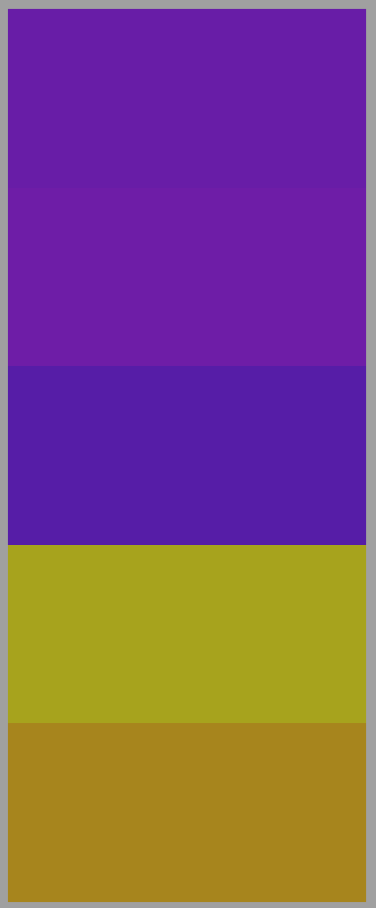

RGB (From Left to Right):

1. 681da7 – Royal Purple
2. 6e1da7 – Lighter Purple
3. 561da7 – Deeper Purple
4. a7a31d – Golden
5. a7851d – Orange-ish

Color theme: Analogous

Why: The colors look great together, but you wouldn’t find them in the wild together.

Where: I would use them on a royal heraldry set, because the Purple + Gold combo is a commanding color, and draws a lot of attention to itself.

3rd Color Palette:

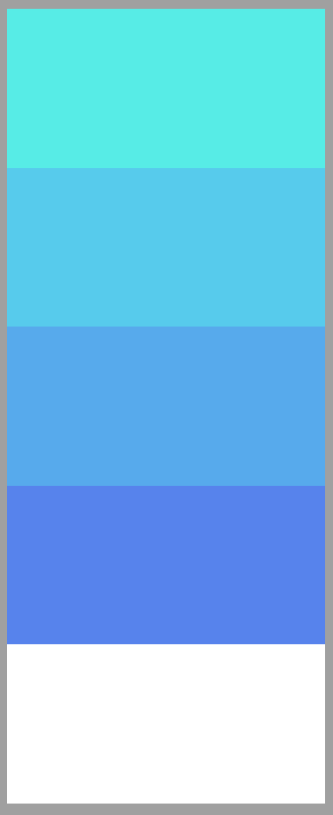

RGB (From Left to Right):

1. 57ece6 – Very light blue
2. 57cbec – Light blue
3. 57aaec – Medium blue
4. 5783ec – Deep-ish blue
5. ffffff - White

Color theme: Cool

Why: Blue is a color that goes great with itself (In my opinion)

Where: I would use it for an ice level, and that’s why I added the white in as the last color, for snow.

4th Color Palette:

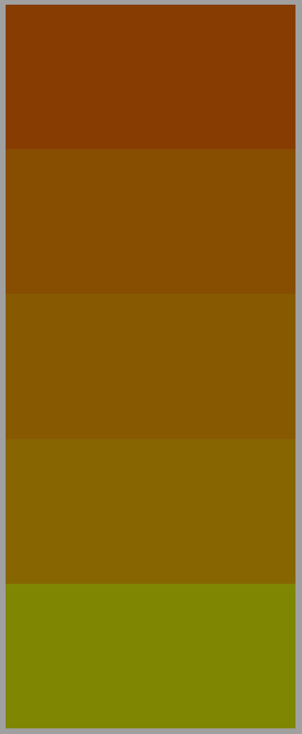

RGB (From Left to Right):

1. 874e02 -- Reddish
2. 873d02 – Dark Orange
3. 875a02-- Medium Orange
4. 7f8702 – Light Orange
5. 876602 - Yellowish

Color theme: Warm

Why: The warm colors look good together.

Where: I would use it for either a sun-scorched desert or a mesa, because the warm but dull colors seem to fit those vibes.

5th Color Palette:



RGB (From Left to Right):

1. 720000 – Light(er) Red
2. 600101 – Dark Red
3. 000000 – Black
4. 2f2f2f – Dark Grey
5. 4b4b4b – Light Grey

Color theme: Dark

Why: The black scale looks great, but it has to have some sort of a color to look at or it gets boring.

Where: I was thinking for evil enemies (like the dread knight I submitted for the enemies’ piskel drawing)